**INTERNSHIP**

**PROJECT REPORT**

**Loan Approval Using Artificial Intelligence and Machine Learning**



**Hexnbit Online Internship**

**www.hexnbit.com**

*Intern Detail*

LOAN APPROVAL USING AI-ML MODEL.

**Name of Project:** ………………………………………………………………………………………………………………….

RAHUL KUMAR NARRA.

**Name of Intern:**  ………………………………………………………………………………………………………………….

9959305185

**Intern’s Ph. no.:**  ………………………………………………………………………………………………………………….

1-106/A, M.A.RAJULA KANDRIGA,K.V.B PURAM MANDAL,CHITTOR,A.P-517643.

**Intern’s Add.:**  ………………………………………………………………………………………………………………….

SAVEETHA SCHOOL OF ENGINEERING.

**Name of College:** ………………………………………………………………………………………………………………….

Saveetha University, Saveetha nagar, Thandalam, Tamil Nadu-602105.

**College’s Add.: ……..**………………………………………………………………………………………………………….

COMPUTER SCIENCE ENGINEERING (CSE).

**Branch:**  ………………………………………………………………………………………………………………….

15/10/2020

**Project Submission Date:** ………………………..

*Table of content*

|  |  |  |
| --- | --- | --- |
| S.No. | Headings | Page No. |
| 1 | Project Application | 1 |
| 2 | List of Hardware’s and software’s used | 2 |
| 3 | Flow Chart | 3 |
| 4 | Project Description | 4 - 6 |
| 5 | Code | 7 - 8 |
| 6 | List of References | 9 |

*Project Application*

**The Application of the Project is to predict the Loan Approval Using AI and Ml Model for the Customers with Help of the details that are given in the CSV file like Gender, Marital Status, Education, Number of Dependents, Income, Loan Amount, Credit History and others. In this Project we able to do different Exploratory Data Analysis with help of different Graphs.**

**To automate this process, they have given a problem to identify the customers segments, those are eligible for Loan amount so that they can specifically target these customers. This is a standard supervised classification task. A classification problem where we have to predict whether a loan would be approved or not by the Bank.**

*List of Hardware & Software used*

**List of Software:**

* Windows 10.
* JUPYTER NOTEBOOK.
* ANACONDA (python) and so on.

**List of Hardware:**

* 4GB of RAM
* CPU with 2 x 64 bits OS, 2.8 GHZ
* INTEL - i3 (7th Generation ) and so on

*Flow chart*

**The PROCESS USED IN THIS AI-ML MODEL :**

**We are going to follow the same steps which are given in the above flow chart in an order to predict approval of the Loan amount with AI-ML model.**

*Project Description*

**Below is the dataset attributes with description:**

| **Variable** | **Description** |
| --- | --- |
| Loan_ID | Unique Loan ID |
| Gender | Male/ Female |
| Married | Applicant married (Y/N) |
| Dependents | Number of dependents |
| Education | Applicant Education (Graduate/ Under Graduate) |
| Self_Employed | Self employed (Y/N) |
| ApplicantIncome | Applicant income |
| CoapplicantIncome | Coapplicant income |
| LoanAmount | Loan amount in thousands |
| Loan_Amount_Term | Term of loan in months |
| Credit_History | credit history meets guidelines |
| Property_Area | Urban/ Semi Urban/ Rural |
| Loan_Status | Loan approved (Y/N) |

We are going to predict the Loan Approval Using AI-Ml Model with help of Libraries or packages which are in python by using above description and variables which are in the table.

**The chances of getting a loan will be higher for:**

* Applicants having a credit history (we observed this in exploration.
* Applicants with higher applicant and co-applicant incomes
* Applicants with higher education level.
* Properties in urban areas with high growth perspectives  
  So let's make our model with 'Credit History', 'Education' & 'Gender'

**Libraries:** We use different libraries for Loan-Prediction of AI-ML Model which are given below.

* pandas
* matplotlib
* seaborn
* scikit-learn

**Algorithms:** The Algorithms that are used in Model for Classification are:

* Logistic Regression
* Decision Tree
* Random Forest
* Extra Tress

After Classifying different models like Logistic Regression, Decision tree, Random Forest Etc. I suggest the Logistic Regression because it has high Accuracy and Cross Validation. And I think it is fit for this model.

**Best Model Accuracy:** 77.27 (Logistic Regression)

**LOGISTIC REGRESSION:**

Logistic regression is a supervised learning classification algorithm used to predict the probability of a target variable. Mathematically, a logistic regression model predicts P(Y=1) as a function of X. It is one of the simplest ML algorithms that can be used for various classification problems such as spam detection, Diabetes prediction, cancer detection etc.

It’s an S-shaped curve that can take any real-valued number and map it into a value between 0 and 1, but never exactly at those limits.

1 / (1 + e^-value)

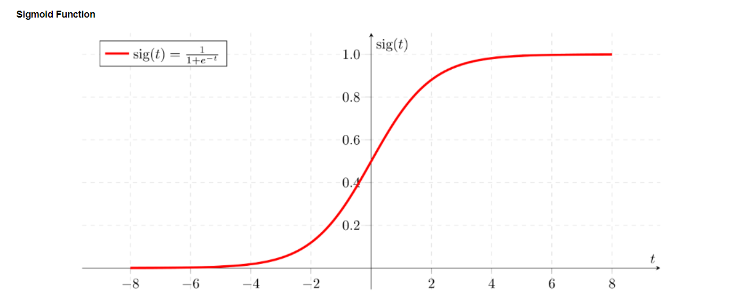

Finally, we can able to predict the customers who are able to get the Loan amount with help of AI-ML Model.

**FUTURE SCOPE OF PROJECT:**

The future scope of the Project is to get more details from the Customers like their credit card details, their past transactions amounts and to predict their Loan approval by Automation of AI AND ML MODEL. We can also Use simple UI\UX design which is connected to the back end of the program and they can check easily about their Loan Approval whether they get Loan or Not.

*Code*

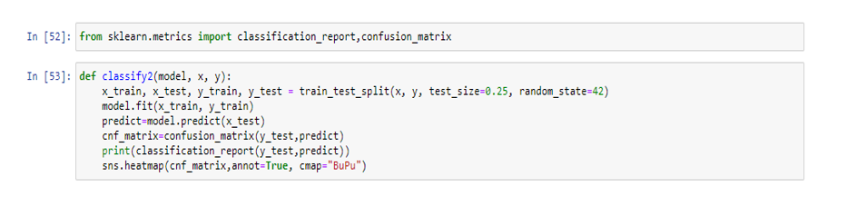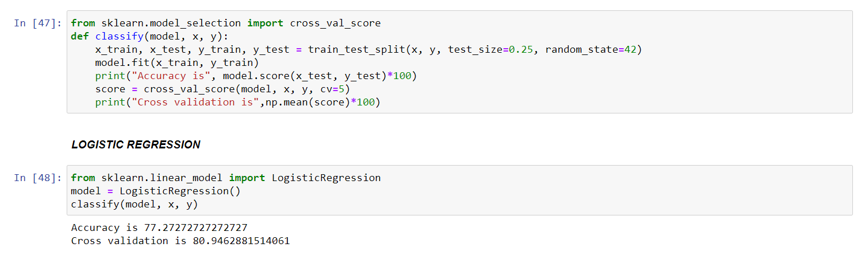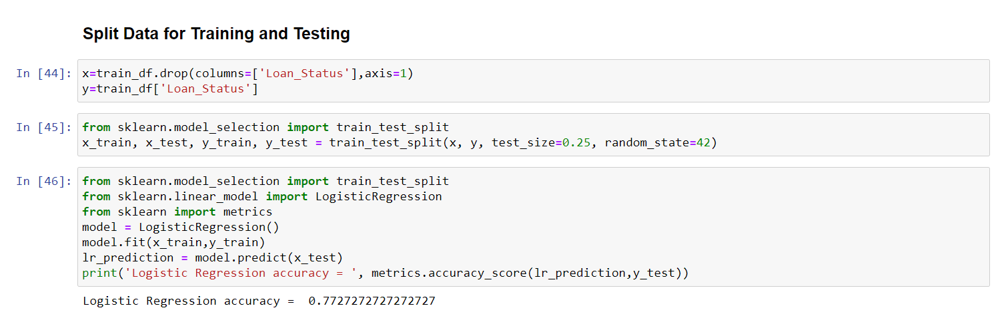**After Training and Testing the Data the logistic regression code will be :**

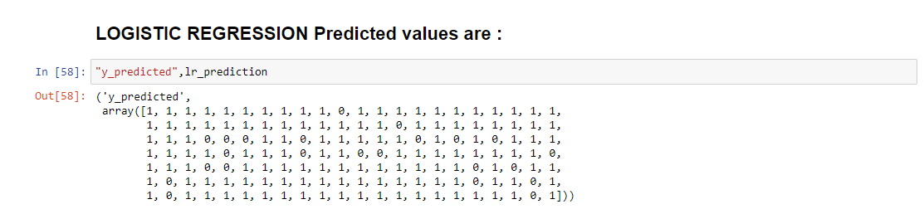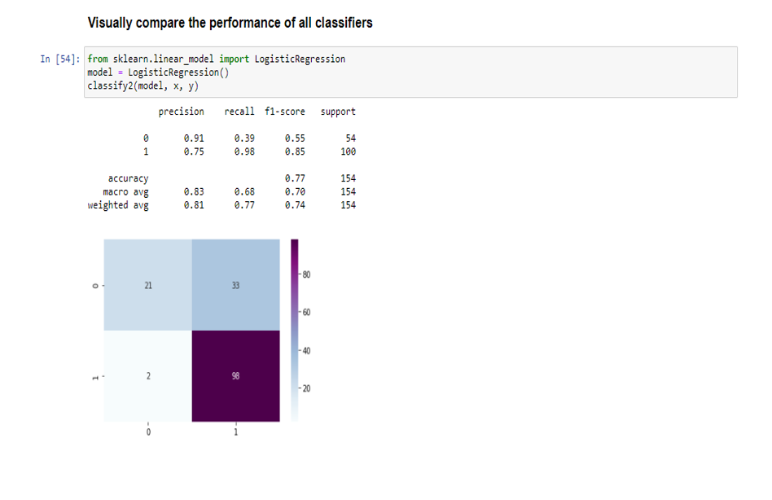

*List of References*

* <https://github.com/ParthS007/Loan-Approval-Prediction>
* <https://github.com/limchiahooi/loan-approval-prediction>
* <https://github.com/KeithGalli/pandas>
* <https://github.com/aswintechguy/Machine-Learning-Mini-Projects>